



**MODEL 335 USER MANUAL**

**Thank you for purchasing the SNAPnGO Model 335 Electric Scooter from Glion. The SNAPnGO is a top-quality electric scooter that will provide years of enjoyment. This manual contains instructions for assembling and operating your electric scooter. Please read and understand this manual fully before assembling and operating your scooter. Please also view in their entirety our Assembly Video and Operating Video on our website** [**www.getglion.com**](http://www.getglion.com)**. If you still have any questions after reading this manual and viewing the videos, please visit our website, send us an email, and/or give us a phone call.**

**We are here to help.**

**Website: www.getglion.com/support**

**Email: support@getglion.com**

**Phone: 855-500-2640**

**WARNING: ENSURE THAT THE GLION SNAPNGO IS RIGHT FOR YOU.**

**The intended use of this electric scooter is to provide mobility to persons with full use of their upper and lower extremities and who are able to support themselves in an upright position. This product is primarily for indoor use and the outdoor capabilities are limited to hard, flat, and even surfaces such as concrete, black top, and other similar surfaces. This product is not a medical device and is not intended to assist, treat, diagnose, or alleviate any medical condition or disability.**

A mobility scooter is not a toy. It is an electrically powered scooter and failure to follow safe operating procedures and safety warnings at all times could result in serious personal injury or death in addition to the injury or death of others. Driving a mobility scooter requires a combination of healthy traits and abilities, including but not limited to good vision; strength; coordination; balance and concentration. If you have these traits and abilities, you are on the right track. Additionally, to safely operate the Glion SNAPnGO, you must be able to:

• Read and understand all Glion SNAPnGO reference materials, including this User Instructional Manual and all Glion SNAPnGO safety instructions contained in this Manual.

• Stand and walk independently or with limited assistance.

• Have sufficient hand strength to operate the throttle and brake.

• Maintain and shift balance to accommodate inclines, declines, and turns as described in this User Manual and other Glion SNAPnGO safety instructions.

• Steer and control the mobility scooter.

• See pedestrians and vehicles.

• Judge speeds, distances, and slopes.

• Recognize hazards and obstacles in your path.

• Be patient enough to slow down, stop and wait whenever necessary.

• Mount or dismount the mobility scooter without assistance or risk of falling.

• Easily get the mobility scooter in and out of its storage place.

• Use both hands on the handlebars.

***NOTE: This owner’s manual is compiled from the latest specifications and product information available at the time of publication. We reserve the right to make changes as they become necessary. Any changes to our products may cause slight variations between the illustrations and explanations in this manual and the product you have purchased. The latest/current version of this manual is available on our website*** [***www.getglion.com***](http://www.getglion.com)***.***

***NOTE: Please register your Glion Electric Scooter at*** [***https://getglion.com/product-registration***](https://getglion.com/product-registration) ***to activate your warranty. Registration also helps us ensure your continued satisfaction and contact you with any product/safety updates. To register your scooter, you will need the scooter’s serial number. It is located on the back of the seat post base. See diagram on page 22.***

**TABLE OF CONTENTS**

SAFETY SPECIFICATIONS AND OWNER OBLIGATIONS 4

ADDITIONAL SAFETY GUIDELINES 7

GLION SNAPNGO MODEL 335 SPECIFICATIONS 21

GLION SNAPNGO MODEL 335 PARTS DIAGRAM 21

OPEN BOX ASSEMBLY (see Open Box/Assembly Video at getglion.com) 22

OVERVIEW OF YOUR GLION SNAPNGO ELECTRIC SCOOTER 33

OPERATING YOUR SNAPnGO ELECTRIC SCOOTER 35

BATTERY AND CHARGER 40

GENERAL TROUBLESHOOTING 44

CLEANING, STORING, AND SERVICING 45

PRODUCT REGISTRATION 46

GLION SNAPnGO LIMITED WARRANTY 46

# SAFETY SPECIFICATIONS AND OWNER OBLIGATIONS

1. **SAFETY INSTRUCTIONS.** The below instructions and tips will help you to operate your Glion SNAPnGO safely. PLEASE NOTE - The Glion SNAPnGO scooter is designed to be used by one person at a time only and is not recommended for any person younger than 16 years old.

• Read this Manual and all safety and training instructions and all warning labels before operating the Glion SNAPnGO. **Failure to follow the instructions in this manual and those located on your scooter can lead to personal injury and/or damage to the scooter, including voiding the warranty.**

• Do not carry passengers or exceed the maximum weight capacity.

• Do not mount or dismount the Glion SNAPnGO unless it is resting at a complete stop, on a level surface, parking brake engaged and is turned off.

• Comply with all local laws and regulations while operating the Glion SNAPnGO.

• Check that the folding mechanism is securely locked before use.

• Always slow down before changing directions, turning, or descending a slope.

• Always keep both hands on the handlebars and both feet on the footrests when operating the Glion SNAPnGO.

• Always approach small obstacles straight on and at slow speeds. Do not attempt to drive over potholes, puddles, or any other road hazards. Use common sense when operating the Glion SNAPnGO. Reckless driving can result in an accident!

2. **SAFE OPERATING CONDITIONS:**

* Do not operate this scooter in traffic.
* Be very careful with inclines. Read below sections for details.
* Do not operate this scooter on surfaces that are wet, frozen, oily, or unpaved.
* Never carry passengers or objects that can hinder your ability to safely operate this scooter.
* Never use headphones or a cell phone to talk or text while riding.
* Do not exceed the maximum weight capacity.

3. **PREGNANT OPERATORS**: Pregnant women should not operate this scooter.

4. **DRIVING IMPAIRED:** Never use alcohol or drugs before or while operating this scooter. The use of such hinders your ability to safely operate the scooter.

5**. STUNTS:** This scooter is not designed for stunts or tricks and should not be used as such. High speeds, two-wheel tilted driving, jumps, wheelies, and other trick maneuvers are dangerous and can result in loss of control, accidents, and injury/death to self or others.

6. **INCLINES:** Never operate this scooter on steep inclines (inclines that have slopes steeper than a standard handicap ramp). Always climb and descend inclines slowly and go straight up and straight down. Do not attempt turns on inclines. When climbing inclines, you may need to use a higher power setting (setting 3) to increase the climbing torque of the scooter. If the scooter loses momentum and comes to a stop on an uphill, quickly apply the hand brake and put both feet on the ground. Get off the Glion SNAPnGO and walk the product either up or down the incline.  **The scooter has a short wheelbase and a high center of gravity. It may become unsteady at excessive speeds. Avoid excessive speeds that can be associated with downhill rides.** When going downhill, always actuate the brakes to control the speed. The scooter has a manual handbrake and an electronic motor brake. The scooter must be turned on for the electronic motor brake to work. Always turn the power switch on to enable the electronic brake and check the brakes BEFORE beginning to go downhill. Never go downhill without the electronic brake being enabled.

** WARNING: Failure to control your speed or attempting a sharp turn when descending a hill can result in serious injury or death.**

7. **GUEST USE:** Never permit a guest to use this scooter unless the guest has read the user manual and all the warnings. Never allow more than one person at a time to ride the scooter. Never exceed the maximum weight capacity.

** WARNING: This product should not be used by persons unwilling or unable to take responsibility for their own actions.**

8. **INSURANCE:** YOUR INSURANCE POLICIES MAY NOT PROVIDE COVERAGE FOR ACCIDENTS INVOLVING THE USE OF THIS MOTOR SCOOTER. TO DETERMINE IF COVERAGE IS PROVIDED, CONTACT YOUR INSURANCE COMPANY OR AGENT **BEFORE** USING THE SCOOTER.

9. **OPERATOR AGE:** Do not allow anyone under the age of 16 to operate this scooter. This scooter is designed for operation by and the transport of only one-person age 16 or older.

10**. SURROUNDINGS:** Ride your scooter in a controlled environment away from vehicles, obstacles, and other hazards. Never operate the scooter near steps or swimming pools. Do not drive the scooter on grass, gravel, or any other textured or bumpy surface.

11**. INTENDED USE:** The intended use of this scooter is to provide mobility to persons with full use of their upper and lower extremities and who are able to support themselves in an upright position. This product is primarily for indoor use and outdoor capabilities are limited to hard, flat, and even surfaces such as concrete, black top and other similar surfaces. While we understand the scooter’s outdoor capabilities are limited, when driving near uneven obstacles, follow the safety guidelines outlined within the safety section of the user manual. This product is not a medical device and is not intended to assist, treat, diagnose, or alleviate any medical condition or disability.

This scooter is not designed or intended for stunts or tricks, including but not limited to jumps, operating on two wheels only or operating while standing on the scooter. Always stay seated, keep both hands on the handlebars, both feet on the foot pedals and all three wheels touching the ground while operating the scooter.

12. **SPEED:** The scooter’s maximum speed is approximately 9.5 kmh (6 mph) at Power Setting 3. Setting 3 also gives the scooter the most torque or power for climbing inclines. For your safety, use Setting 1 (under 5kmh or 3mph) for flat surface driving and be careful to control your speed when descending hills or turning. The scooter has a short wheelbase and can become unsteady at excessive downhill speeds or sharp turns. Do not use Setting 2 (7kmh or 4.5mph) or Setting 3 while making turns or descending hills.

13. **VISIBILITY:** Do not ride your scooter at night or in conditions of poor visibility. If riding in such conditions is unavoidable, drive slowly, turn on the headlamp/tail light and wear reflective clothing or vest.

** WARNING: Riding at dawn, dusk, or at times of poor visibility without a lighting system that meets state and local laws, and without approved reflectors, is illegal, dangerous, and can result in serious injury or death.**

14. **TEMPERATURE**: Do not use the scooter when the temperature is below -5 C (23 degrees F).

15**. WEATHER CONDITIONS:** Avoid riding in wet or icy conditions.

** WARNING: Wet or icy weather impairs traction, braking, and visibility for riders and other vehicles and pedestrians sharing the roads. The risk of accident is dramatically increased in wet or icy conditions.**

16. **SURFACE CONDITIONS:** The scooter is intended for use on hard, flat, dry paved surfaces without loose debris such as sand, leaves, rocks, or gravel. Wet, slick, bumps, uneven or rough surfaces may impair traction and contribute to possible accidents**. Do not ride your scooter in mud, grass, gravel, sand, ice, or water. Watch out for potential obstacles that could catch your wheel or force you to swerve suddenly or lose control. Avoid sharp bumps, drainage grates and sudden surface changes.**

17. **WATER RESISTANCE:** Although some water resistance measures have been implemented, riding the scooter through standing water, rain, wet or muddy conditions runs the risk of severely damaging it. Do not immerse the scooter in water or directly spray the scooter when cleaning. When parked outside where rain is possible, cover the handlebar controls with water resistant materials to protect the electric controls.

18. **SAFETY WHEN NOT RIDING**: When the scooter is not being used for riding, place it in a safe, stable, and secured environment; keep it away from fire, water and other hazards.

19. **PURCHASER’S AGREEMENT:** By accepting delivery of this product, you promise you will not change, alter, or modify this product or remove or render inoperable or unsafe any guards, shields, or other safety features of this product; fail, refuse, or neglect to install any retrofit kits from time to time provided to enhance or preserve the safe use of this product.

20. **SHIPPING AND DELIVERY:** Before using your scooter, make sure your delivery is complete as some components may be individually packaged. If you do not receive a complete delivery, please contact us at [support@getglion.com](mailto:support@getglion.com) immediately.

***NOTE: If you ever lose or misplace your copy of this manual, contact us at*** [***support@getglion.com***](mailto:support@getglion.com) ***and we will be glad to send you a new one immediately.***

# ADDITIONAL SAFETY GUIDELINES

Your scooter is a state-of-the-art, life-enhancement device designed to increase mobility. Please be aware that the final selection and purchasing decision regarding the type of scooter to be used is the responsibility of the scooter user, who is capable of making such a decision.

**WARNING! Do not operate** **your scooter for the first time without completely reading and understanding all information available with your scooter, including but not limited to safety labeling, owner’s manuals, and instructional videos.**

**WARNING! The Glion SNAPnGO is not intended for use by persons who cannot support themselves in an upright position.**

**WARNING! Prior to operating your scooter, familiarize yourself with the location and use of controls, including the tiller for steering, the throttle for accelerating, and the handbrake for stopping. During operation, unless gripping the handbrake, always keep both hands on the handlebars to assure safe operation of the scooter. Failure to both release the throttle and engage the handbrake when stopping the scooter can result in collision with people or objects which may result in property damage, personal injury, or death.**

**WARNING! The Glion SNAPnGO is intended for operation on flat, even surfaces whether indoors or outdoors. Examples of “indoors” typically include, but are not limited to, linoleum, hardwood, tile, non-pile, and low-pile carpeting. Examples of “outdoors” typically include, but are not limited to, concrete, asphalt, and refined brick configurations. Do not operate your scooter on or near uneven surfaces such as stairs, drop-offs, ledges, grass, gravel, sand, mulch, dirt, mud or deteriorated concrete, asphalt, or other uneven surfaces. Failure to heed this warning may result in damage to the product or cause instability and tipping resulting in personal injury or death.**

The following are precautions, tips, and other safety considerations intended to help you become accustomed to operating your scooter safely. While we recognize that scooter users will frequently develop skills to manage daily activities that may differ from those illustrated in this manual, it is imperative that all safety guidelines in this manual be followed to ensure user safety. Failure to follow the safety notices in this and other manufacturer supplied manuals and those located on your scooter can lead to personal injury and/or damage to the scooter and may result in voiding the product warranty.

**Modifications**

We have designed and engineered your scooter to provide maximum mobility and utility. Under no circumstances should you modify, add, remove, or disable any feature, part, or function of your scooter.

**WARNING! Do not modify your scooter in any way not authorized by Glion. Do not use accessories if they have not been tested or approved for the scooter. Glion approved accessories must be installed by your authorized Dealer or a qualified service technician.**

**WARNING! The addition of accessories to the scooter may change the overall weight, size, and/or center of gravity of your scooter. It is important to take note of these changes to avoid damage to the scooter and surrounding property.**

**WARNING! Do not add any side body anti-tip wheels or other side body stability enhancements. Doing so may diminish ground clearance and promote instability when the user comes in contact with any raised surface. We acknowledge certain high weight capacity products have side body anti-tip wheels. These are intended to enhance product stability during transfer on and off of the scooter and do not enhance the dynamic stability of the scooter.**

The center of gravity of your seat was factory set to a position that meets the needs of the demographic majority of users.

**WARNING! Do not change your seating configuration without first contacting your authorized Dealer. Only your authorized Dealer or a trained service technician should make adjustments to the seat.**

**WARNING! Do not use seats on your scooter that have not been tested or approved for your scooter. Using unapproved seats could affect the center of gravity of your scooter, resulting in a tip or a fall.**

You should not modify the electrical system in any way not authorized by the scooter manufacturer.

**WARNING! Do not connect any aftermarket or auxiliary devices to the scooter electrical system or use the scooter batteries to power any aftermarket or auxiliary devices unless you are using an adapter that has been tested and approved by the scooter manufacturer. Do not cut or splice any original equipment wires, cables, or leads for the purpose of adding aftermarket or auxiliary devices to the scooter as this may result in damage to the electrical system and batteries.**

**WARNING! Do not pull on electrical leads directly to detach them from the scooter. Always grasp the plug or connector itself when disconnecting the lead to prevent wire damage.**

**WARNING! Ensure that the charger power cord connectors are clean and dry before plugging the connectors into either the charger socket or the electrical socket. Inspect the charger power cord regularly for damage to the insulation, frayed wires, or any other damage. Do not use your charger if damaged.**

**WARNING! In the event of a loss of power to the scooter, transfer to a safe position, seeking assistance if needed. Contact Glion or your authorized Dealer immediately to report the incident.**

**Weight Limitations**

Your scooter is rated for a maximum weight capacity. Please refer to the product specifications table for this limit. Keep in mind that the maximum weight capacity includes the combined weight of the user and any accessories mounted to the scooter. Stay within the specified weight capacity of your scooter. Exceeding the weight capacity voids your warranty. We will not be held responsible for injuries and/or property damage resulting from failure to observe weight limitations.

**WARNING! We recommend that you do not use the scooter as a seat during weight-training activities or as a weight-training apparatus. Such use can lead to undue stress and fatigue on scooter components, and can also affect center of gravity, resulting in a tip or a fall. We will not be held responsible for injuries and/or property damage resulting from use of the scooter in weight-training activities or as a weight-training apparatus.**

**WARNING! Do not use the scooter to haul, move, or tow other vehicles, including lawn mowers, ATV equipment, or other mobility devices. Your scooter was not designed with such use in mind and any damage or injury incurred from such use is not the responsibility of the scooter manufacturer.**

**WARNING! Do not carry passengers on your scooter. Carrying passengers on your scooter may affect the center of gravity, resulting in a tip or a fall. We will not be held responsible for injuries and/or property damage caused by carrying passengers on the scooter.**

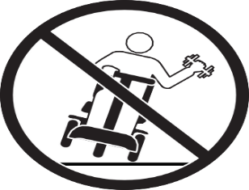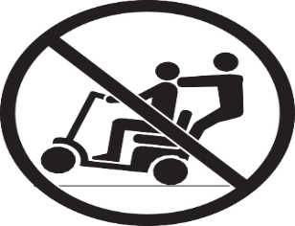

**Incline Information**

More and more buildings have ramps with specified degrees of inclination, designed for easy and safe access. Some ramps may have turning switchbacks (180-degree turns) that require you to have good cornering skills on your scooter.

* Proceed with extreme caution as you approach the downgrade of a ramp or other incline.
* Take wide swings with your scooter’s front wheel around any tight corners. If you do that, the scooter’s rear wheels will follow a wide arc, not cut the corner short, and not bump into or get hung up on any railing corners.
* When driving down a ramp, keep the scooter’s speed adjustment set to the slowest speed setting to ensure a safely controlled descent.
* Avoid sudden stops and starts.

When climbing an incline, try to keep your scooter moving. We recommend you climb inclines in power setting 3 for maximum climbing torque. If you must stop, start up again slowly, and then accelerate cautiously. When driving down an incline, set your scooter to the slowest speed setting and drive in the forward direction only. If your scooter starts to move down the incline faster than you anticipated or desired, release the thumb throttle and engage the manual brake lever slightly until you reach your desired speed.

**WARNING! When stopping on any sort of an incline or decline, ensure the parking brake is engaged.**

**WARNING! When climbing an incline, do not zigzag or drive at an angle up the face of the incline. Drive your scooter straight up the incline. This greatly reduces the possibility of a tip or a fall. Always exercise extreme caution when negotiating an incline.**

**WARNING! You should not travel up or down potentially hazardous inclines, including but not limited to areas covered with snow, ice, cut grass, wet leaves, or gravel.**

**WARNING! Never travel down an incline or ramp backward. Doing so may cause the scooter to tip. Always exercise extreme caution when negotiating an incline**.

Handicap public-access ramps are not subject to government regulation in all countries, and therefore do not necessarily share the same standard degree of slope. Other inclines may be natural or, if man-made, not designed specifically for scooters. Your scooter’s ability to travel up inclines is affected by your weight, travel speed, angle of approach to the incline, and your scooter setup, including seat configuration and power setting. Therefore, we recommend that the maximum slope of an incline you attempt to safely ascend or descend on your scooter does not exceed the maximum allowable incline listed in the product specifications. We also recommend you climb inclines in power setting 3 for maximum climbing torque. Refer to the following table for standard degree of slope guidelines that are available for regions as noted. **See Table below.**

**WARNING! Your scooter has been tested in accordance with certain standards. You should not exceed the performance specifications of your scooter as noted in the product specifications.**

**WARNING! Any attempt to climb or descend a slope steeper than that specifically listed in your scooter product specifications may put your scooter in an unstable position and cause it to tip.**

**WARNING! Don’t carry anything or add any accessory that will adversely affect the center of gravity or exceed the weight capacity of the scooter. Doing so could affect the center of gravity of the scooter, resulting in a tip over**.

|  |  |
| --- | --- |
| **Geographic Location** | **Minimum Safe Slope Requirement** |
| USA (Americans with Disabilities Act–ADA) | ADA requires 5° (8.7%) |
| Europe (CE mark) Class A | 3° (5.2%) |
| Europe (CE mark) Class B | 6° (10.5%) |
| Europe (CE mark) Class C | 10° (17.6%) |



When you approach an incline, it is best to lean forward. This shifts the center of gravity of you and your scooter toward the front of the scooter for improved stability. **See figures 1 and 2 below.**

**Figure 1. Normal Position Figure 2. Increased Stability Position**



**Figure 3. Safe Pushing**

**Braking Information**

The Glion SNAPnGO is equipped with three brake systems: a manual handbrake lever, an electric motor brake and a parking brake. The brake lever must be activated manually to slow the vehicle to a near stop. Refer to “Overview” and “Operating Your Scooter” sections for braking information.

The speed of your scooter is controlled by a thumb throttle and the power setting. When the thumb throttle is depressed, the scooter will begin to move forward. The further you depress the thumb throttle, the faster the vehicle will move up to a preset maximum speed. When the thumb throttle is released back to the default position, the electric brake will be engaged, and forward acceleration is stopped. The manual handbrake must be engaged to come to a controlled stop. There are three power settings. Power setting 1 is the slowest power setting. Power setting 3 is the fastest power setting.

***NOTICE: If the thumb throttle is released while climbing an incline, the scooter may “roll back.” You must engage the manual brake lever to stop the scooter from rolling back down the incline.***

**Cornering Information**

Excessively high cornering speeds can still create the possibility of tipping. Factors which affect the possibility of tipping include, but are not limited to cornering speed, steering angle (how sharply you are turning), uneven surfaces, inclined surfaces, riding from an area of low traction to an area of high traction (such as passing from a tiled area to a carpeted area – especially at high speed while turning), and abrupt directional changes. High cornering speeds are not recommended. If you feel that you may tip over in a corner, reduce your speed and steering angle (i.e., lessen the sharpness of the turn) to prevent your scooter from tipping.

**WARNING! When cornering sharply, reduce your speed and maintain a stable center of gravity. Avoid shifting your weight in the opposite direction of the turn, which may cause the scooter to lose traction and tip over**.

**Stationary Obstacles (Steps, Curbs, etc.)**

Proceed with extreme caution when driving near raised surfaces, unprotected curbs and/or drop-offs (curbs, porches, stairs, etc.). Refer to the scooter specifications for information regarding maximum obstacle climbing height for your scooter.

**To navigate up over a curb or stationary obstacle:**

1. Approach the curb or obstacle slowly, and make sure the scooter is traveling perpendicular to the obstacle. **See figure 4.**
2. Increase the forward speed just before the front wheel comes in contact with the obstacle.
3. Reduce the forward speed only after the rear wheels have cleared the obstacle.

**To navigate down a curb or stationary obstacle:**

1. Approach the curb or obstacle slowly, and make sure the scooter is traveling perpendicular to the obstacle. **See figure 4.**
2. Reduce the forward speed just before the front wheel comes in contact with the obstacle.
3. Increase the forward speed only after the rear wheels have cleared the obstacle and you are once again on a level surface.

**CURB**

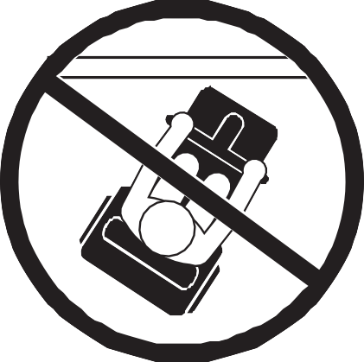

**CURB**

Figure 4 Correct Curb Approach Figure 5 Incorrect Curb Approach

**WARNING! Even though your scooter may be capable of handling greater obstacles, we recommend that you do not attempt to negotiate a curb that has a height greater than 1.5 in. (4 cm). Doing so could cause instability in your scooter.**

**WARNING! Do not attempt to have your scooter climb or descend an obstacle that is inordinately high.**

**WARNING! Do not attempt to have your scooter proceed backward down any step, curb, or other obstacle. This may cause the scooter to tip.**

**WARNING! Do not approach curbs at an angle; instead, approach any curb you intend to ascend or descend in the forward position.**

**WARNING! The Glion SNAPnGO is intended for operation on flat, even surfaces whether indoors or outdoors. Examples of “indoors” typically include, but are not limited to, linoleum, hardwood, tile, and non-pile and low-pile carpeting. Examples of “outdoors” typically include, but are not limited to, concrete, asphalt, macadam, and certain refined brick configurations. Do not operate your scooter on or near uneven surfaces such as stairs, drop-offs, ledges, grass, gravel, sand, mulch, dirt, mud or deteriorated concrete, asphalt or other uneven surfaces. Failure to heed this warning may result in damage to the product or cause instability and tipping resulting in personal injury or death.**

**Ingress of Liquids**

**WARNING! Even though the scooter has passed the necessary testing requirements for ingress of liquids, you should keep electrical connections away from sources of dampness, including direct exposure to water or bodily fluids and incontinence. Check electrical components frequently for signs of corrosion and have them replaced as necessary.**

**WARNING! Never take your scooter into a shower, tub, pool, or sauna. Do not operate your scooter in water.**

**Stairs and Escalators**

Scooters are not designed to travel up or down stairs or escalators. Always use an elevator.

**WARNING! Never use your scooter to negotiate stairs or escalators.**

**WARNING! Use extreme caution when it is necessary to move an unoccupied scooter up or down stairs. We recommend that two attendants perform this task, and that the seat, battery, and any accessories be removed before attempting the transfer. Use proper lifting techniques and use only solid, non-removable frame components to lift the scooter.**

**Elevators**

Modern elevators have a door edge safety mechanism that, when pushed, reopens the elevator door(s). If you are in the doorway of an elevator when the door(s) begin to close, push on the rubber door edge or allow the rubber door edge to contact the scooter and the door will reopen.

Use care that pocketbooks, packages, or scooter accessories do not become caught in elevator doors.

**Doors**

* Determine if the door opens toward or away from you.
* Drive your scooter gently and slowly forward to push the door open or push your scooter gently and slowly backward to pull the door open.

**Unoccupied Motor Vehicle Transport**

Do not remain seated in your scooter while traveling in a motor vehicle. The scooter should be stowed folded in the trunk of a car or in the back of a truck or van with seat removed and/or properly secured. In addition, all removable scooter parts should be removed and/or properly secured during motor vehicle transport.

**WARNING! The scooter user should never sit on the scooter while it is in a moving vehicle.**

**WARNING! Always be sure your scooter and its seat are properly secured when it is being transported. Batteries should not be transported with any flammable or combustible items.**

**Seating**

WARNING! Do not remove the seat cushion supplied with the scooter. Do not place additional cushions, padding, or pillows on the seat cushion. This could cause an unstable position, resulting in a fall from the scooter. Should the fittings on your seat become loose, report the problem immediately to Glion or your authorized dealer.

**Batteries and Charging: Lithium-Ion**

In addition to following the warnings below, be sure to comply with all other battery handling information provided in the “Battery and Charger” section of this owner’s manual beginning on page 42.

**WARNING! Airlines have strict guidelines for transporting Lithium-Ion batteries onboard passenger airplanes. Check with airline prior to travel. Don’t assume the same rules apply on your return flight.**

**WARNING! Only use batteries and chargers authorized by Glion.**

**WARNING! This battery has been tested and complies with United Nations Transport Regulations standard UN38.3.**

**WARNING! Always ensure that the Lithium-Ion battery charger supplied with your scooter is used to recharge your battery. Using a different or non-Lithium charger voids your warranty and may result in product damage, personal injury, or death.**

**WARNING! Always protect the battery from freezing and never charge a frozen battery. Charging a frozen battery may result in damage to the battery.**

**WARNING! Always operate charger in a well-ventilated area as it is essential for proper cooling. Ensure vent holes are clear of blockages before use and always place the charger on a hard, flat surface during charging. Before each use, ensure the charger is not covered with any items such as blankets or articles of clothing. Do not place the charger in enclosed areas such as pouches or bags when charging. Failure to allow for proper ventilation may result in damage to the charger.**

**WARNING! Check battery case for signs of damage. If the battery case appears damaged, do not charge or use your battery and contact Glion or your authorized Dealer immediately.**

**WARNING! Be aware that the battery charger case may become hot during charging. Avoid skin contact and do not place the charger on surfaces that may be affected by heat including carpeting or clothing.**

**WARNING! If the battery charger is equipped with cooling slots, then do not attempt to insert objects through these slots and keep the cooling slots free from objects.**

**WARNING! Do not charge in direct sunlight or near heat sources.**

**Removable Parts**

**WARNING! Do not attempt to lift or move your scooter or seat by grasping or holding onto any of its removable parts. Grasp only solid, non-removable frame components to lift or move your scooter or seat**.

**Preventing Unintended Movement**

**WARNING! If you anticipate being seated in a stationary position for an extended period of time, power off the scooter. This will prevent unexpected motion from inadvertent thumb throttle contact. This will also eliminate the possibility of unintended scooter movement from electromagnetic (EM) sources**.

**Reaching and Bending**

Never reach, lean, or bend while driving your scooter. Bending forward creates the risk of accidental thumb throttle contact. Bending to the side while seated creates the risk of tipping. If it is necessary to reach, lean, or bend while seated on your scooter, it is important to maintain a stable center of gravity and keep the scooter from tipping. Make sure the wheels are pointed in the forward position to create the longest possible wheelbase. We recommend that the scooter user determine his/her personal limitations and practice bending and reaching in the presence of a qualified attendant. **See figures 6 and 7.**

**WARNING! Do not bend, lean, or reach for objects if you must pick them up by reaching down between your knees, if you have to lean from either side of the scooter, or if you have to reach over the back of the seat. Movements such as these may change your center of gravity and the weight distribution of the scooter. This may cause your scooter to tip.**

**WARNING! Keep your hands, clothing, and all other objects away from the tires when driving. Do not allow any personal belongings or objects to drag behind the scooter when driving. Be aware that loose fitting clothing or other objects can become caught in drive wheels and/or they may become entangled in the running gear.**

**WARNING! Possible strangulation hazard! Be aware that clothing, lanyards, necklaces, other jewelry, purses, and other accessories worn or carried by you while you are seated on or operating the scooter may get caught around the armrests or moving parts. Be careful to avoid this potential danger.**

**WARNING! Do not allow objects or accessories to protrude from your scooter when driving**. **Be aware protruding objects can become caught on items surrounding the scooter’s path.**

**Figure 6 Below Left -Proper Reaching and Bending. Figure 7 Below Right -Improper Reaching and Bending.**

Figure 7

Figure 6

**Transfers**

Transferring on and off your scooter requires a good sense of balance. Always have an attendant present while learning to properly transfer. To eliminate the possibility of injury, we recommend that you or a trained attendant perform the following tasks before attempting a transfer:

* Turn power off.
* Ensure the parking brake is engaged and make sure the seat is fixed securely in place.

**WARNING! Before transferring, engage the parking brake.**

**WARNING! Before transferring, position yourself as far back as possible in the scooter seat to prevent the scooter from tipping forward during transfer.**

**WARNING! Avoid putting your weight on the scooter tiller or handlebar. Such use may cause the scooter to tip, resulting in a fall from the scooter and personal injury.**

**WARNING! Avoid putting your weight on the scooter foot pedals. Such use may cause the scooter to tip or the pedals to break. When standing up, put both feet securely on the ground (not the foot pedals) and then stand up.**

**Physical Limitations**

Users must exercise care and common sense when operating a scooter. This includes awareness of safety issues that arise because of particular physical limitations of the scooter user.

**WARNING! Do not operate your scooter if your ability to operate the scooter safely is impaired in any way. Examples include, but are not limited to, a lack of awareness of surroundings or lack of capacity to think clearly; impaired vision or hearing; or impaired dexterity of upper extremities that limits the capacity to use controls or steer. Operating this scooter while impaired in any way may result in erratic steering, acceleration, braking, instability, tipping, misdirection, and/or collision with persons or objects. Any of these circumstances can result in serious personal injury or death**.

**Drugs/Medications**

Users must exercise care and common sense when operating a scooter. This includes awareness of safety issues that arise when taking prescribed or over-the-counter drugs/medications.

**WARNING! Consult with your physician if you are taking prescribed or over-the-counter drugs/medications. Some drugs/medications may impair your ability to operate your scooter safely. Operating this scooter while impaired may result in erratic steering, acceleration, braking, instability, tipping, misdirection, and/or collision with persons or objects. Any of these circumstances can result in serious personal injury or death**.

**Alcohol and Other Intoxicants/Smoking**

Users must exercise care and common sense when operating a scooter. This includes awareness of safety issues that arise after consuming alcohol and other intoxicants, including marijuana and various forms of narcotics.

**WARNING! Do not operate your scooter while you are under the influence of alcohol or other intoxicants, including marijuana and other forms of narcotics, which may impair your ability to operate your scooter safely. Operating this scooter while impaired may result in erratic steering, acceleration, braking, instability, tipping, misdirection, and/or collision with persons or objects. Any of these circumstances can result in serious personal injury or death**.

**Smoking**

Users must exercise care and common sense when operating a scooter. This includes awareness of safety issues that arise from smoking which may impair your ability to operate your scooter in a safe manner.

**WARNING! Do not operate your scooter while smoking. Smoking may impair your ability to operate your scooter safely or cause a fire. Operating a scooter while smoking can distract the user from safely operating the scooter and can interfere with properly operating the scooter’s controls which may result in erratic steering, acceleration, braking, instability, tipping, misdirection, and/or collision with persons or objects. Any of these circumstances may result in serious personal injury or death. Smoking while operating the scooter can also result in physical burns and/or scooter/property damage and can ignite a fire that can result in serious personal injury or death.**

**WARNING! We strongly recommend that you do not smoke cigarettes while seated in your scooter. You must adhere to the following safety guidelines if you decide to smoke cigarettes while seated in your scooter.**

* + **Do not leave lit cigarettes unattended.**
  + **Keep ashtrays a safe distance from the seat cushions.**
  + **Always make sure cigarettes are completely extinguished before disposal.**

**Flammability Precautions**

**WARNING! Even though the plastics and seat used on your scooter have been tested and have passed flammability standards, we recommend that you do not expose your scooter to open flames.**

**WARNING! Exercise extreme caution when using oxygen near electrical circuits and combustible materials. Contact your oxygen dealer for information on using oxygen safely.**

**WARNING! Replace worn or damaged upholstery immediately to reduce the risk of fire hazard.**

**WARNING! Be aware that washing of upholstered items may reduce the resistance to flammability of the fabric**.

**Hazardous Environments**

**WARNING! Due to the electrical make-up of our products, we do not recommend use of our scooters in Class I Division I industrial or commercial environments where the work area could have a combustible air composition. In such an environment, it is possible for the scooter to become an ignition source for a fire or explosion**.

**Sports and Athletics**

The scooter user must exercise care and common sense when operating his/her scooter. This includes awareness of safety issues while participating in sports and athletics. All sports activities run the risk of injury. We recommend that your scooter be equipped with a positioning belt and that you use sports safety equipment such as helmets and padding if you choose to participate in sports activities.

**WARNING! Participating in sports and athletics is done at the user’s own risk. The scooter user is responsible for using proper safety equipment and for ensuring that his/her scooter is properly configured for such use. We will not be held liable for personal injury and/or product damage resulting from use of the scooter in any sports-related activity.**

**Electromagnetic and Radio Frequency Interference (EMI/RFI)**

**WARNING! Laboratory tests have shown that electromagnetic and radio frequency waves can have an adverse effect on the performance of electrically powered mobility vehicles**.

Electromagnetic and Radio Frequency Interference can come from sources such as cellular phones, mobile two- way radios (such as walkie-talkies), radio stations, TV stations, amateur radio (HAM) transmitters, wireless computer links, microwave signals, paging transmitters, and medium-range mobile transceivers used by emergency vehicles. In some cases, these waves can cause unintended movement or damage to the control system. Every electrically powered mobility vehicle has an immunity (or resistance) to EMI. The higher the immunity level, the greater the protection against EMI. This product has been tested and has passed at an immunity level of 3 V/m.

**WARNING! Be aware that cell phones, two-way radios, laptops, electricity generators or high-power sources, and other types of radio transmitters may cause unintended movement of your electrically powered mobility vehicle due to EMI. Do not turn ON hand-held personal communication devices, such as citizens band (CB) radios and cellular phones, while the scooter is turned on. Be aware of nearby transmitters, such as radio or TV stations, and avoid coming into close proximity to them.**

**WARNING! The addition of accessories or components to the electrically powered mobility vehicle can increase the susceptibility of the vehicle to EMI. Do not modify your scooter in any way not authorized by the scooter manufacturer.**

**WARNING! The electrically powered mobility vehicle itself can disturb the performance of other electrical devices located nearby, such as alarm systems.**

***NOTICE: For further information on EMI/RFI, contact Glion or your authorized Dealer. If unintended motion occurs, turn your scooter off as soon as it is safe to do so. Contact Glion or your authorized Dealer to report the incident.***

**Additional Safety Tips:**

* Fully charge batteries before operating. Corrosive chemicals are contained in batteries. Battery has been tested and complies with United Nations Transport Regulations standard UN38.3. Check with airline prior to travel. Protect battery from heat sources or water such as open flame or sparks. Do not transport batteries with flammable or combustible items. Keep tools and other metal objects away from battery terminals. Battery terminals contact with metal can cause electric shock.
* Do not allow unsupervised children to play near the scooter while the batteries are charging. Do not connect an extension cord to the AC/DC converter or the battery charger.
* Your product must be disposed of according to applicable local and national statutory regulations. Contact your local waste disposal agency or authorized dealer for information on proper disposal of packaging, metal frame components, plastic components, electronics, batteries, neoprene, silicone, and polyurethane materials.
* When traveling in a motor vehicle, do not sit in your scooter.
* Do not use a cell phone, walkie-talkie, laptop, or other radio transmitter while operating.
* Do not tamper with, modify, or attempt to repair the mobility device. Contact Glion or your authorized Dealer for service or repair.
* Avoid exposure to rain, snow, ice, salt, or standing water whenever possible. Maintain and store in a clean and dry environment.
* Keep your hands, clothing, and all other objects away from the tires when driving. Do not allow any personal belongings or objects to drag behind the scooter when driving. Be aware that loose fitting clothing or other objects can become caught in drive wheels and/or they may become entangled in the running gear.

**Questions & Answers about Proposition 65**

**What is Proposition 65?**

Proposition 65 requires businesses to provide warnings to Californians about significant exposures to chemicals that cause cancer, birth defects, or other reproductive harm. These chemicals can be in the products that Californians purchase, in their homes or workplaces, or that are released into the environment. By requiring that this information be provided, Proposition 65 enables Californians to make informed decisions about their exposures to these chemicals.

Proposition 65 also prohibits California businesses from knowingly discharging significant amounts of listed chemicals into sources of drinking water. Proposition 65 requires California to publish a list of chemicals known to cause cancer, birth defects, or other reproductive harm. This list, which must be updated at least once a year, has grown to include approximately 900 chemicals since it was first published in 1987.

**What types of chemicals are in the Proposition 65 list?**

The list contains a wide range of naturally occurring and synthetic chemicals that include additives or ingredients in pesticides, common household products, food, drugs, dyes, or solvents. Listed chemicals may also be used in manufacturing and construction, or they may be byproducts of chemical processes, such as motor vehicle exhaust.

**What does a warning mean?**

If a warning is placed on a product label or posted or distributed at a workplace, a business, or in rental housing, the business issuing the warning is aware or believes that it is exposing individuals to one or more listed chemicals. By law, a warning must be given for listed chemicals unless the exposure is low enough to pose no significant risk of cancer or is significantly below levels observed to cause birth defects or other reproductive harm.

**Where can I get more information on Proposition 65?**

If you have specific questions on the administration or implementation of Proposition 65, you can contact OEHHA’s Proposition 65 program at [P65.Questions@oehha.ca.gov,](mailto:P65.Questions@oehha.ca.gov) or by phone at (916) 445-6900.

**User Safety Notice**

Your safety is important to us. If there is any information in this manual which you do not understand, or if you require additional assistance for setup or operation, please contact your authorized Dealer.

**Failure to follow the instructions, warnings, and notes in this manual and those located on your product can result in personal injury or product damage and will void the product warranty.**

** WARNING: Please register your electric scooter with us. If you don’t, we may not be able to contact you directly with important safety information.**

Please register your Glion Electric Scooter at https://getglion.com/product-registration/. Please keep your original proof of purchase in a safe place in the event of a warranty claim. **Scooter serial number is located on the back of the seat post base. See Parts Diagram on page 21.**

# GLION SNAPNGO MODEL 335 SPECIFICATIONS

|  |  |  |
| --- | --- | --- |
| Size | Unfolded Dimension | 40x26x32 inch |
| Folded Dimension | 40x26x16 inch |
| Frame Net Weight | 1 14 kg (31.3 lb) |
| Detachable Battery Weight | 1.5 kg (3.3 lb) |
| Travel Seat Weight | 1.66 kg ( 3.6 lb) |
| Deluxe Seat | 5.25 kg (11.5 lb) |
| Performance | Maximum Load | 136 KG (300 lb) |
| Top Speed (Setting 3)  Setting 2  Setting 1 | 12 km/h* (6mph)  7km/h (4.5mph)  3-4km/h (3mph) |
| Range | 21 km* (13 miles) |
| Battery | Voltage | 36V |
| Type | Li-ion Battery |
| Capacity | 6.4AH |
| Motor | Type | Brushless DC Motor |
| Rated Output Power | 250W |
| Charger | Input Voltage | 100-240V |
| Charging time | 3.5h |

**\*** Top speed and range per charge depends on rider weight, wind speed, temperature, riding style, riding surface, battery condition, and other factors. Actual top speed and range per charge may vary**.**

# GLION SNAPNGO MODEL 335 PARTS DIAGRAM

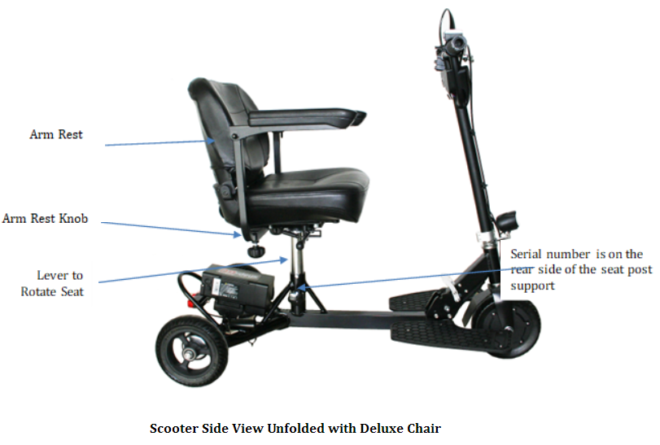

**OPEN BOX ASSEMBLY (see Open Box/Assembly Video at getglion.com)**

**VERY IMPORTANT:** Please go to our website <https://getglion.com/videos/> and select Glion SNAPnGO to watch our Unboxing/Assembly Video and our Operating Video. Use the following instructions as additional assistance. If you have any questions or concerns, always feel free to contact our customer support. Also, please register on our website for manufacturer’s warranty.

Lift the scooter frame out of the box. Because of its weight and size, we suggest it be done by two people.

You should have the following items in the box:

1 scooter frame, 1 deluxe seat, 1 seat base, 1 seat post, 1 seat post knob, 2 arm rests, 2 arm rest knobs, 1 battery, 1 charger, 2 keys for the battery, 1mirror, 1canvas pouch, 1 wire handlebar basket, 2 wire side baskets, brackets and hardware, 2 foot rests with hardware and a tool kit.

Step 1: Set the scooter on a stable surface. Cut all the shipping zip ties and remove wrapping material. **Watch the video “Unboxing/Assembly”** for details.

**FOOT REST INSTALLATION**

Step 1: Stand scooter up vertically on its 2 rear wheels and rear bumper (Vertical Self Standing Position) for easy access before installing the footrests. You can find 3 bolt holes on each side of the flanges at the bottom of the neck shown below. Footrests are bolted onto the flanges. Please note: there are 2 settings for each footrest. The factory default is BACK position. If you prefer to extend your feet more forward while riding, you can adjust to FORWARD position by re-bolting the foot rests to the supporting beams.

Vertical Self Standing

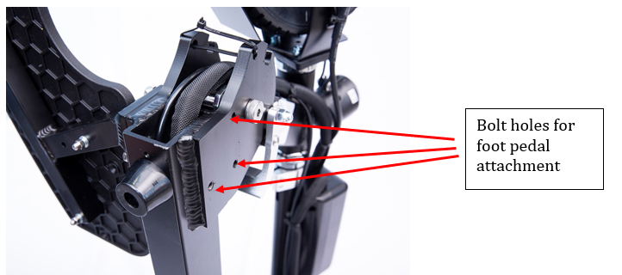

Step 2: Using the wrench, bolts and washers provided, attach the foot rests to the flanges with the flat washer against the scooter frame and the lock washer between the flat washer and the bolt head.

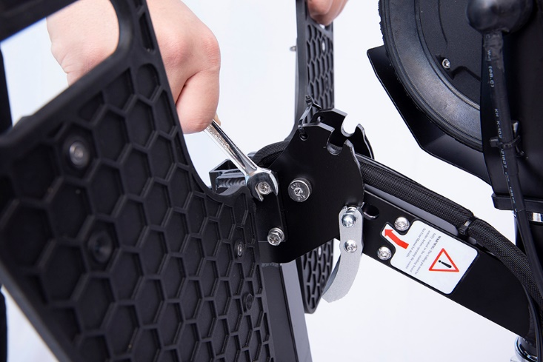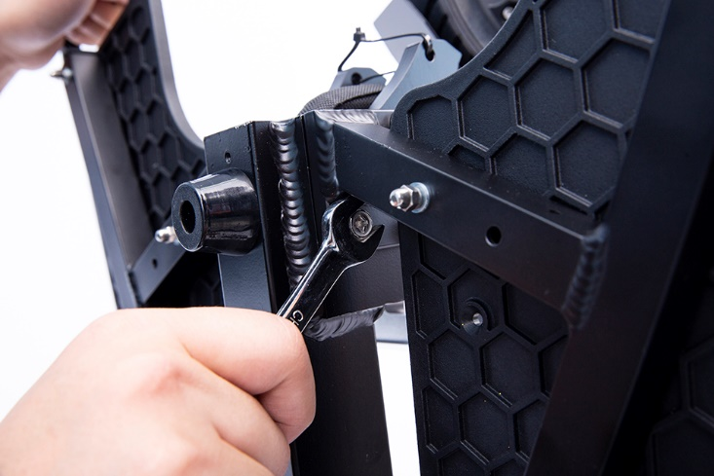

**UNFOLD/FOLD INSTRUCTIONS**

**For video instructions, please visit our website at getglion.com. We encourage you to view the video instructions prior to unfolding/folding operation to avoid damage to your Glīon scooter.**

**UNFOLDING YOUR SCOOTER:**

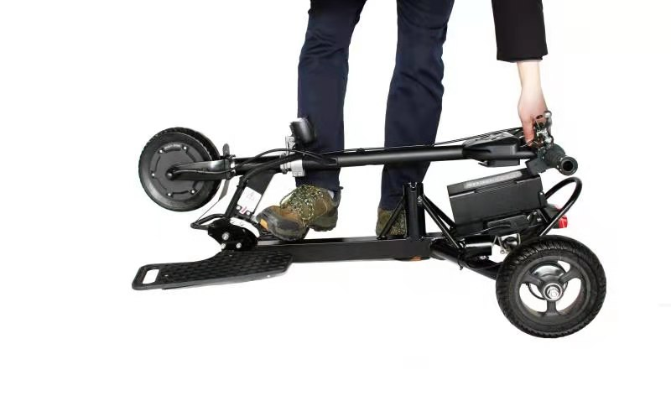

Hold the handlebar

Step on the folding pedal

Step on the folding pedal to release the folding lock and lift the handlebar. Push the handlebar forward until you hear a click, which means the folding pin is locked in securely.

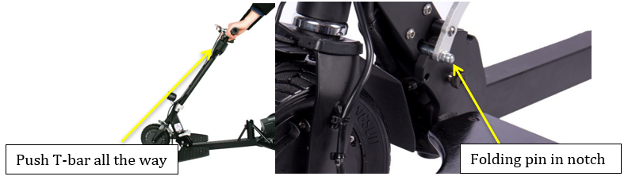

**VERY IMPORTANT: Push the T-bar all the way forward and make sure the folding pin is fully seated in its notch. (You will hear a “click”, which is the sound of folding pin hitting the bottom of the notch).**

**FOLDING YOUR SCOOTER:**

**Make sure the scooter is off.** **While pushing the T-bar forward a little (takes any back pressure off the folding pin)**, **put one foot on the folding pedal and press**. **It should unlock. Let the handlebar fold down till you hear a “click”. It should lock into the folding position by itself. Very important: pushing the T-bar forward allows the folding mechanism to release so you can press the folding pedal using your foot. Without pushing the T-bar forward while pressing the folding pedal could damage the folding mechanism.**

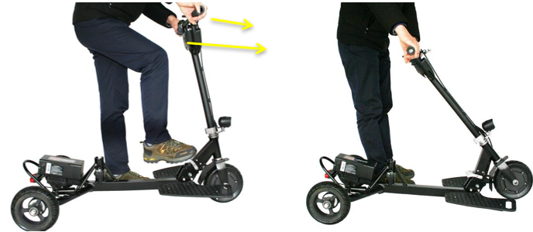

Push T-bar forward to release the pressure on locking mechanism while stepping on the folding pedal. **Note: No need to use force from foot, just rest the foot on the folding pedal until the handlebar folds down**.

# Vertical SELF Standing InstructionS

Travel seat bundled with the scooter

After you fold the scooter, you can lift the front wheel up and have the scooter stand vertically. In the vertical self-standing position, you can insert the seat post into the collar on driver’s side and insert the travel seat into the collar on passenger’s side. You can also use the included bungee cord to secure the deluxe seat to the scooter. Then you can dolly the scooter around the same as you would a roller bag suitcase.

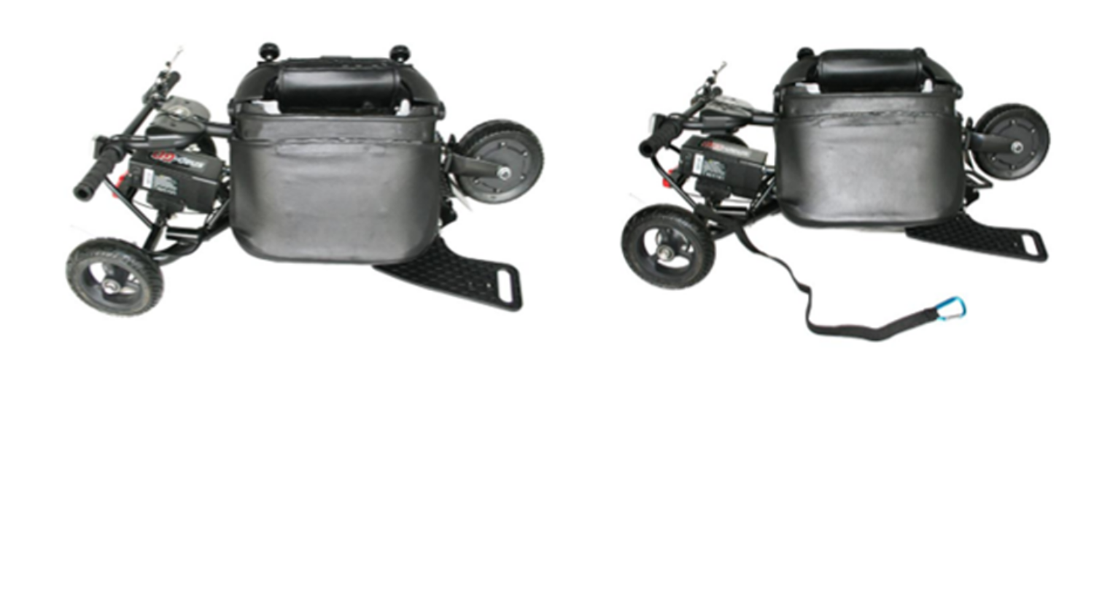

**Seat INSTALLATION**

Your SNAPnGO electric scooter comes with two seat options: Deluxe Seat (Standard) and Travel Seat (Optional). They both share the same seat post. The deluxe seat base comes with four positions to allow various distances from seat to handlebar. Using the bolts install the seat base in the ideal position for you.

Insert the silver seat post into the scooter seat post frame and make sure the pin is fully seated in the notch. Insert the deluxe seat into the silver seat post and lock in place.

Armrest: insert the armrest into the armrest holder under the seat. Adjust the armrest position to find the most comfortable width and use the knob to securely tighten it. You can raise and lower the armrest if needed.

Swivel lever: The deluxe seat comes with a swivel function. While sitting on the seat, pull the swivel lever forward to unlock the seat and use your body to swivel the seat.

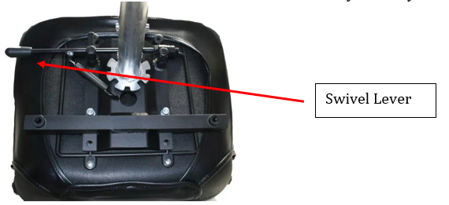

Travel Seat: Insert the seat post into the scooter frame. Then insert the travel seat into the seat post.

You can use the included bungee cord to bundle a carry-on suitcase with the scooter while using the travel seat. Hook one end of the bungee cord to the seat post support and through the rear bumper. Lay luggage flat on top of the battery and rear bumper. Wrap the bungee cord around the luggage and hook the other end to the seat post support.

**Basket Installation**

Your SNAPnGO electric scooter has 1 wire front basket, 2 wire side baskets and 1 canvas pouch for your various cargo needs.



**WARNING**: For your safety, the maximum load capacity for your front pouch is 6 lbs. The maximum load capacity for each basket is 10 lbs. Pay special attention when the side basket is loaded. Always slow down to speed setting 1 (2 mph or walking speed) when using side baskets as the additional side loading could shift center of gravity and add risk of side tipping, especially when scooter is making turns at high speed. Try to balance your load on both sides and make sure to check surrounding environment and turn slowly when you need to make a turn.

**WARNING**: Do not use side baskets with the travel seat as the hanging brackets could interfere with leg movement when embarking/disembarking the scooter creating a scraping hazard.

To install the pouch, hang the pouch hooks onto the T-bar (**make sure the hooks go under the braking wire before latching onto the T-bar so that the hooks do not press on the braking wire**) and close the Velcro band around the handlebar down tube.

To install the front basket, simply hang its hooks onto the T-bar (**make sure the hooks go under the braking wire before latching onto the T-bar so that the hooks do not press on the braking wire**) and have the front basket bottom bracket securely lean against the handlebar down tube.

Side baskets are for your additional cargo needs. You do not need to install them if the front basket is adequate for your daily needs. You need to first install the included hanging brackets onto the silver seat post. The longer end should face forward. Make sure bracket fitting notch fits onto the notch on the seat post. Using Allen wrench and included bolts and nuts attach the 2 brackets securely to the post. Then you need to install the leaning brackets onto the basket. Center the 2 plates on both sides of the basket and secure them with included bolts. The bracket extension should face outside of the basket so that it could lean against the scooter frame to support the weight of load in the basket. The bottom of the leaning bracket should be about 2 inches above the bottom of the basket. The tip of the leaning brackets should rest securely against the scooter frame spine when basket is hung on the hanging bracket. Refer to online installation video if more detail is needed.

**OVERVIEW OF YOUR SNAPnGO ELECTRIC SCOOTER**

** WARNING: SNAPnGO was designed to make everyday mobility easy. However, there are still certain risks that users should be aware of when operating a SNAPnGO electric scooter such as injury from loss of control, tipping over, collisions or falls. It is your responsibility to learn how to safely ride the SNAPnGO to potentially reduce these risks. Our website and support materials outline the potential hazards of driving the SNAPnGO. Prior to riding the SNAPnGO take time to read and understand all support materials including this User Manual which contains safety instructions. Any questions regarding any information contained in this Manual, our website, any support materials, or any other general questions should be sent by email to support@getglion.com or called in to our customer service representatives at (855) 500-2640.**

1. **A picture containing device

   Description automatically generatedPowering On/Off and Battery Indicator:** To turn the scooter on, you must press the on/off switch as shown below **(S) once**. The Battery Indicator LED Light (**S1**) will indicate the power is on by lighting. If all 3 lights are on, it means the battery is at least 50% full. If only 2 lights are on, battery is below 50%. If only 1 light is on, battery is approaching empty and may have 1 mile left. Note: the battery indicator light is accurate only when the throttle tab (**S2**) is NOT engaged. When throttle is pressed, the reading could be LOWER than actual as the instant current will alter the voltage reading from battery. If the LED is not lit, the scooter is turned off. The scooter will automatically turn off after five minutes of non-use. **To turn the power off, you must press the on/off switch and hold it for at least 2 seconds**. **The scooter is on electronic braking when power is on and if the right accelerator is not pressed. If you need to push the scooter manually, turn off the power.**
2. **Headlight On/Off:** To turn the headlight/tail light on or off, you must first turn on the scooter power (S). While the scooter power is on, press the power button (S) once, the headlight and rear light should be turned on. Press (S) one more time, the headlight & rear light will be turned off.
3. **Accelerator:**  The right thumb control is the accelerator (S2). The further you press the accelerator down, the more energy you will release to the motor. **NOTE**: **As a safety feature, the motor will be in the default “braking” mode when the LED is on and when the accelerator is not pressed**. Read below “Speed Setting Controls” to understand speeds. Operate your SNAPnGO at a reasonable speed for both your personal safety and others. **CAUTION – Do not make turns at high speeds or on steep inclines. Your SNAPnGO may tip over.**
4. **Reverse control:** The reverse control (T1) is located on the left side. When switch is forward set to F position, it means forward. When switch is set to R position, it means reverse. The reverse mode has a top speed of 2-3mph and does not change speed regardless of speed setting. If the scooter is on reverse mode, scooter will move backward when throttle (S2) is pressed.
5. **Brake:** The left brake handle is the mechanical brake **(H)** that activates dual drum brakes located on the rear wheels. The scooter is on electronic braking when power is on and the right accelerator is not pressed. When the brake lever is squeezed, it will cut power supply to the motor. **The electronic brake only works when the scooter is turned on**. The parking brake tab (H1) could be actuated by pressing towards the brake lever when the brake lever (H) is squeezed. Squeeze brake lever (H) one more time to release the parking brake (H1). See details in the Parking Brake section. **In a safe, controlled environment, please familiarize yourself with the braking distance of the scooter at different speeds before operating near intersections, pedestrians, and other obstacles.**
6. **Speed setting control (T2):** Toggle the speed setting to control the maximum speed of the scooter. The speed for setting 1 is 3-4 kmh or 2 mph, 2 is 7-8 kmh and 3 is 10-12 kmh. We recommend speed 1 as your default setting. Speed setting 3 has the most torque and speed. Operate your SNAPnGO at a reasonable speed for both your personal safety and for the safety of others. Always slow down before turning.
7. **Horn (G):** When power is on, you can press the horn (G) to give alerts.

 **WARNING: Do not make turns at high speeds or on steep inclines. Your Glion SNAPnGO may tip over. Before turning, slow down. Go straight up and straight down inclines.**

** WARNING: For your safety and for the safety of others, please take the time to practice accelerating, turning, braking and familiarize yourself with the scooter’s braking distance in an open and safe area before taking your scooter out into the general environment. IT IS YOUR RESPONSIBILITY TO MAINTAIN CONTROL OF YOUR SCOOTER AT ALL TIMES!**

**OPERATING YOUR SNAPnGO ELECTRIC SCOOTER**

Just like learning to drive a car or ride a bicycle, operating any personal transportation device inherently includes risk and takes practice. Therefore, use caution as you practice operating the scooter in various situations. Keep the speed at a reduced level until you’re comfortable controlling the scooter. The below instructions and practice steps will teach you to maneuver through doorways, on and off lifts, and up and down ramps.

When preparing for your first ride, select an area that is flat, spacious, and away from traffic and other obstacles. Bring a friend along to help you follow the instructions while you practice. Start driving with the lowest speed. Please refer to the Overview section of this Manual for instructions on the SNAPnGO’s three speeds.

**Getting Ready:**

1. Fully charge the battery. For safety reasons, the battery is only 50% charged when shipped from the factory (See Battery Charging Instructions Below).
2. Choose a controlled environment away from vehicles, obstacles, and other hazards for riding. **Even if you have experience with motorized scooters, vehicles, bicycles, etc., you must familiarize yourself with the function, handling, turning, ramp climbing, braking distance, performance, and safety of this scooter in a safe and controlled environment.**
3. Always check and obey all local laws and regulations. ***Your insurance policies may or may not provide coverage for accidents involving the use of this motorized scooter. To determine if coverage is provided, check with your insurance company or agent. Do not assume your existing insurance policies provide coverage****.*
4. Unfold the scooter (See Unfolding Instructions above).
5. Complete a final roadworthiness safety check before operation.
   1. Make sure folding mechanism, dolly handle, wheel lug nuts, other nuts, bolts, fasteners, etc., are secure.
   2. Inspect the frame, fork and handlebars for cracks or broken connections.

**Riding the Scooter Powered:**

1. Install foot pedals, the deluxe seat or travel seat onto the scooter frame. Sit on the seat with both feet rested on the foot pedals.
2. Press the on/off button on the thumb throttle once to turn on the scooter. The battery indicator on the thumb throttle should be lit when the scooter is turned on. Make sure on the lefthand side the speed setting is set to 1 and forward/reverse control is set to F for forward mode.
3. With both hands on the handlebars and eyes looking forward, press the right thumb throttle to move forward**.**
4. As the motor begins to slowly propel the scooter forward, practice braking by releasing the right thumb throttle or squeezing the left-hand brake. The scooter should come to a stop.
5. Practice reverse by switching the forward/reverse control to R for reverse and slowly depressing the throttle. Practice braking by releasing the left thumb throttle or squeezing the left-hand brake. The scooter should come to a stop.
6. Press the power switch once to turn on the headlight and tail light. Press it again to turn the lights off.
7. Toggle the speed setting to 2. The scooter should go faster. Switch to setting 1 to slow down the scooter. Practice the same for speed setting 3. Practice the following steps to help you become comfortable with your SNAPnGO.

**Practice Steps:**

1. Learn to use the throttle and brake. With your Left hand, apply pressure to the hand brake. Releasing the hand brake, slowly press the right thumb throttle (throttle) and move the scooter forward five feet. While releasing the throttle, apply the hand brake and come to a complete stop. Repeat this process several times, each time allowing the scooter to venture farther before applying the hand brake to come to a complete stop.

**PLEASE NOTE** – SNAPnGO is a front-wheel-drive scooter. As a result, fast starts can cause its front wheel to spin, which can be dangerous for drivers. Slowly pressing the accelerator each time you start will help to avoid or reduce this condition.

1. Learn to turn. Slowly turn the SNAPnGO by using wide movements. Feel how the scooter reacts to your body weight. Shifting your body weight through the turn will help add stability. As you feel more comfortable, you will be able to make the turns tighter. **Always remember to slow down before turning or changing directions.** Going too fast through a turn will cause the SNAPnGO to tip over. If the SNAPnGO begins to tip, slow the unit down, back off on the turn and place your feet on the ground.
2. Learn to reverse. Prior to engaging reverse (reverse switch control), turn your head to make sure there are not people or hazards such as curbs, parked cars, or walls behind you and then switch to reverse setting and slowly press down on the thumb throttle. Only use the reverse function to move away from an obstacle or back out of an elevator. While in reverse, limit turns or changes in directions. **After completing the reverse operation, always switch the setting back to Forward position.**
3. Avoid steep inclines and hills. The SNAPnGO is not designed to be driven up or down steep inclines or hills. However, the SNAPnGO should be able to drive up all wheelchair ramps which comply with government standards. Leaning your body forward, which places more weight on the front wheel, will aid the scooter up the ramp. Carefully control your speed on the descent. Avoid making turns while going down a hill.

** WARNING: Always ride at speeds you can comfortably and safely control. Take the time to familiarize yourself with the electronic brakes and the distance it takes to come to a complete stop at various speeds. Always keep both hands on the handle grips while operating the scooter. Failure to do so could result in serious injury or death.**

**While riding your SNAPnGO you will encounter many situations which will require that you understand the abilities of your scooter. The SNAPnGO provides reasonable safety on flat and level surfaces but can tip over on uneven, slanted, or inclined surfaces. Additionally, certain outdoor and indoor conditions can create situations where caution is advised. The following guidelines will help you when encountering certain situations.**

**TURNS**

Unlike a two wheeled vehicle, the SNAPnGO CANNOT be “leaned” into a curve. Therefore, it is essential to slow down to a reasonably slow speed before initiating a turn. Use extreme caution when turning on slanted or uneven surfaces. Occasionally you may find yourself negotiating a curve or corner too fast and the inner rear wheel starts to lift off the ground. If this happens, immediately reduce your speed, lessen the steering angle, and shift your upper body toward the wheel that is lifting off the ground.

**INCLINES AND DECLINES**

Incline conditions require special attention to avoid mishaps. The SNAPnGO is not designed to go up steep or long inclines. Be aware that not all ramps are constructed according to government standards. The government standard for wheelchair ramps is 1 inch (2.5cm) rise per foot (30cm) (5º incline).

**WARNING: An incline that is too steep or long can create a dangerous situation. The scooter can lose momentum causing it to slide backwards down the incline or tip over backwards. It is not recommended to drive the scooter on any ramp, incline or hill that doesn't meet government wheelchair ramp standards.**

Tips for driving the SNAPnGO on inclines and declines:

• Never travel up or down on an incline that is potentially hazardous such as one that is wet, icy, slippery, has loose gravel, etc.

• Always start an incline at the base of the hill and not at an angle.

• Shift your upper body towards the handlebars to shift weight to the front wheel.

• Set the speed setting to 3 to give maximum torque. Slowly twist the throttle to move the scooter forward. Once reaching top, switch back to speed setting 1.

• **Never stop the scooter on an incline. Do not zigzag, but travel in a straight line to the top.**

• If the scooter loses momentum, quickly apply the hand brake and put both feet on the ground. Get off the SNAPnGO and walk the product either up or down the incline.

• Go very slowly while driving down a ramp. Do not go down the ramp or hill at a side angle. Try to avoid turns while descending. Keep your hand on the brake handle and slowly apply pressure if the scooter picks up too much speed.

**SPEEDBUMPS AND UNEVEN SURFACES**

Generally, the SNAPnGO can handle slightly uneven surfaces. You should approach each at a reduced speed and in a direct frontal position (perpendicular to the obstacle).

**WARNING: Attempting to drive over speed bumps or uneven surfaces indirectly can cause the product to tip over and can result in serious injury or death.**

**POTHOLES AND PUDDLES**

Avoid all potholes and deep puddles.

**WARNING: Attempting to drive over potholes or uneven surfaces can cause the product to tip over and can result in serious injury or death.**

**INDOOR USE**

Like an electric wheelchair, you are generally permitted to use the SNAPnGO inside of buildings, airports, shopping malls, stores, theaters, etc. Doors can be a challenge when using the SNAPnGO. Approach each door slowly making sure that the rear wheels will make it through the door opening.

**OUTDOOR USE**

The SNAPnGO should only be ridden on smooth hard and ﬂat surfaces. It is not designed for oﬀ-road conditions. Do not use the SNAPnGO in rain or snow nor drive it through puddles of water. Slightly uneven surfaces should be approached at a reduced speed and in a direct frontal position and may require lifting or walking the scooter around the surface. You should not tow anything behind the SNAPnGO**.**

**Parking Brake Instruction**

Your SNAPnGO scooter comes with a 2-Level parking brake design. Level 2 is tighter than level 1.

Squeezing the brake handle should release the parking brake.

**BATTERY AND CHARGER**

Each electric scooter is equipped with a lithium battery and a smart charger designed specifically for each other. **ONLY USE THE CHARGER SUPPLIED BY THE MANUFACTURER TO CHARGE THE BATTERY.** Do not charge the battery with any other charging system. If the battery or charger is damaged due to improper use, the limited manufacturer warranty shall be void. Do not operate the charger near flammable materials such as carpet. Ensure a dry environment. Never allow the charger or cable to come into contact with water as this may result in electric shock. Never touch the charger or cable with wet hands. Disconnect the charger from the outlet if any fault arises during charging. Always pull the plug, not the cable. Do not allow the charger or cables to be damaged or crushed by sharp edges or heat. The charger supplied with the electric scooter should be regularly examined for damage to the cord, plug, enclosure and other parts. In the event of such damage, the scooter must not be charged until the charger has been repaired or replaced. Unplug the charger and disconnect from the scooter when not in use. As a safety mechanism, when the charger stops charging because either the battery is full or the charger is disconnected from the scooter, the charger must be reset by unplugging it from the outlet before it will resume charging.

**BATTERY:**

1. Fully charge the battery before first time operation or after a long period of non-usage (see *Instructions For Charging* below). For safety reasons, the battery is only 50% charged when shipped from the factory. The battery is fully charged when the LED light on the charger turns green.
2. Always charge the battery in a clean, dry location, free of debris.
3. Charge the battery frequently. The battery can be recharged at any time. Do not think that you need to fully deplete the battery before recharging it. In fact, frequent partial discharge/charge cycles will prolong the battery life vs. full discharge/charge cycles. **Tips: For every 10-15 partial discharge, do a full discharge and charge cycle.**
4. Fully charge the battery before storing the scooter for extended periods.
5. When not in use, periodically recharge the battery once every three months.
6. A picture containing diagram

   Description automatically generatedBattery damage due to water, collision, improper storage and other non-normal factors is not covered by the limited manufacturer warranty.
7. 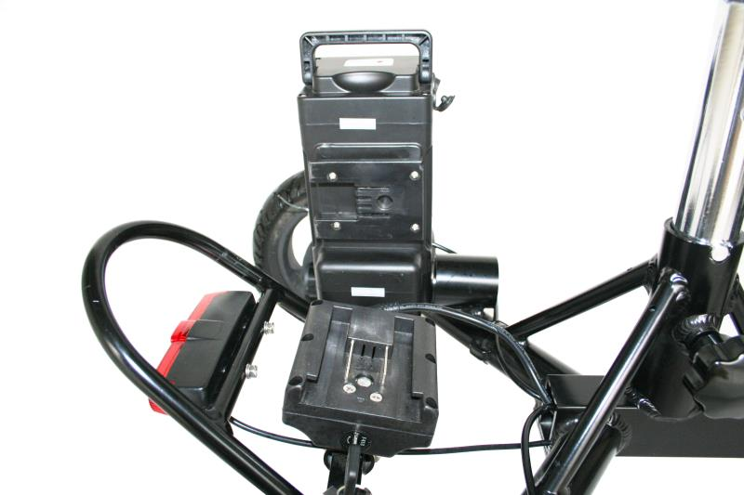SNAPnGO charging port is located on the battery. You can charge the battery when it is attached or detached from the scooter. There are also battery level indicator LED lights on the side of the battery. Pressing it will turn it on. Three green lights means the battery is full. One red light means the battery is low.
8. Detaching the battery: The battery comes with keys (2) to lock and unlock the battery from the scooter frame. We suggest you keep one key with the scooter and one key stored safely as an extra. You cannot detach the battery without a key. Use the key provided to unlock the battery. Slide the battery out of its docking station. Note: To protect your investment, never detach battery and leave the exposed battery docking station in the rain. This will short and damage the battery.

**CHARGER:**

1. The battery is charging when the LED light on the charger is red. When the battery is 100% charged, the light on the charger will go from red to green.
2. The provided charger has a built-in overcharge protection to prevent the battery from being overcharged.
3. Charging time is approximately 3.5 hours for a fully discharged battery.
4. Regularly inspect the charger for damage to the cord, plug, enclosure and other parts. In the event of such damage, the charger must not be used until it has been repaired or replaced.
5. Unplug the charger from the wall outlet when not in use. **As a safety mechanism, when the charger stops charging because either the battery is full or the charger is disconnected from the scooter, the charger must be reset by unplugging it from the wall outlet before it will resume charging.**
6. **Use only the charger supplied with this scooter or a recommended replacement specified by Glīon.**

** WARNING: Failure to confirm compatibility, properly install, operate and maintain any charger, component or accessory can result in serious injury or death.**

**INSTRUCTIONS FOR CHARGING:**

1. Turn the scooter off. Open the charge port rubber protective cover and securely plug the charger into the charge port.
2. Plug the charger into the power outlet.
3. A solid red light on the charger indicates the battery is charging. A solid green light indicates the battery is fully charged.
4. Remove the plug from the power outlet, then remove the charger from the scooter’s charge port. Secure the charge port rubber protective cover to protect port from the elements.

**USAGE:**

1. You will not damage the battery by riding the scooter until the battery is fully discharged and the scooter motor shuts down.
2. Avoid operating the scooter when the battery is hot.

**BATTERY LEVEL INDICATOR**

1. The battery level indicator lights are on the power switch control. When the scooter is turned on, the battery level indicator is on.
2. 3 lights mean the scooter is at least 50% charged. Fewer lights indicate the battery is approaching empty.
3. The battery level indicator is accurate when the motor is **not** engaged. When the scooter is standing still, check the battery level indicator for battery capacity status. Do not check the battery indicator when operating the scooter.
4. **Soft Riding Condition**. When the battery is nearly depleted, a “soft” riding condition can occur. A “soft” riding condition means the scooter can move forward at lower speed but under full speed it shuts down. This occurs because under full speed, a large instant current causes the voltage to drop in the battery reaching the controller stop limit to protect the battery and shutting down the scooter. When this happens, turn the scooter back on and drive the scooter under low speed until you can recharge the battery.

** WARNING: Like any mechanical device, an electric scooter and its components are subject to wear and stress. Different materials and mechanisms wear or fatigue from stress at different rates and have different life cycles. If a component’s life cycle is exceeded, the component can suddenly and catastrophically fail, causing serious injury or death to the rider.** Scratches, cracks, fraying, and discoloration are signs of stress-caused fatigue and indicate that a part is at the end of its useful life and needs to be replaced. While the materials and workmanship of your electric scooter or of individual components may be covered by a warranty for specified period of time by the manufacturer, this is no guarantee that the product will last the term of the warranty. **Product life is often related to the kind of riding you do and to the treatment to which you submit your electric scooter.**

**BATTERY:**

When used normally, the lithium battery provided with your scooter should not lose more than 30% of its capacity within the first 500 charging cycles. Average battery life for a properly maintained lithium-ion battery is approximately 1,000 charge/discharge cycles. If you notice your travel distance significantly diminished despite having a full charge, it is a sign the lithium-ion battery needs to be replaced.

**Fully charge the battery before storing the scooter for extended periods. Periodically recharge the battery at least every 3 months during storage. Leaving the battery depleted and un-charged for more than 3 months could permanently damage the battery and is not covered by warranty.**

**BATTERY DISPOSAL:**

Your Glion product uses lithium-ion batteries, which must be recycled or disposed of in an environmentally safe manner. Do not dispose of a lithium-ion battery in a fire. The battery may explode. Do not dispose of a lithium-ion battery with your household trash. The incineration, landfilling, or combining a lithium-ion battery with your household trash is prohibited in most jurisdictions. Locate a place that collects and recycles lithium-ion batteries. To search online, go to www.call2recycle.org and enter your zip code, or if you prefer to locate a place by phone, dial 1-877-2-RECYCLE to find the nearest retailer that collects lithium-ion batteries.

**MECHANICAL:**

Due to vibration, nuts and bolts can become loose. Make sure that all lug nuts, other nuts and bolts are securely fastened and tighten them if necessary. To test: Pick your scooter up 1-2 inches and bounce it off the ground. Do a quick visual and tactile inspection of the whole scooter. Make sure you inspect all visible nuts, bolts, and structural welds. If anything sounds, feels, or looks loose or shows signs of stress replace or secure them.

**STORAGE AND DAILY CARE**

1. Do not store the scooter in direct sunlight, in damp places, or in temperatures below -5° C (23° F) or above 43° C (110° F).
2. Fully charge the battery every three months if not in use.
3. Keep the scooter clean (See section on Cleaning and Servicing).

**GENERAL TROUBLESHOOTING**

If you experience problems with your scooter, please refer first to the following troubleshooting guide:

**Problem: The scooter does not operate.**

Possible causes/solutions:

1. The scooter is not turned on. **Solution:** Turn on scooter by pressing on/off button.

2. The battery is not charged. **Solution:** Charge Battery.

3. The hand brake is inadvertently engaged. **Solution:** Make sure hand brake is not engaged.

1. The battery is not locked and secured. **Solution:** Secure battery by locking it to the frame using the key provided.
2. The on/off switch on the battery is off. **Solution:** Turn switch on by pressing straight line side of battery switch down.

**Problem: The Scooter Operates Intermittently.**

Possible causes/solutions:

1. The battery is low on charge causing soft riding condition. See page 45 above for description of soft riding condition. **Solution:** Recharge Battery.
2. The battery is not locked and secured into its base. **Solution:** Secure battery by locking it to the frame using the key provided.

**Problem: Short ride time/runs slow.**

Possible causes/solutions:

1. Rider weight. **Solution:** Do not exceed 136 kg (300 lbs.) maximum weight limit.
2. Riding conditions. **Solution:** Use only on flat, dry surfaces. Avoid inclines and areas with debris on surface.
3. Battery not fully charged. **Solution:** Charge battery until full.
4. Old/Damaged Battery. **Solution:** Replace Battery. Contact Customer Service on our website: [www.getglion.com](http://www.getglion.com).

**Problem: Motor has clicking noise when it is first started.**

Possible causes/solutions:

1. This is normal as clicking noise means the motor is reaching its power limits under the current speed setting. If the speed setting is 1, which means the lowest power, the motor is working hard under speed limit when the scooter moves from speed zero. Once the scooter gets moving or is geared up, the noise will go away.

**Problem: Charger LED light stays blue after connecting charger to outlet and battery.**

Possible causes/solutions:

1. Charger needs to be reset. Charger experiencing temporary short circuit. **Solution:** Unplug the charger from the outlet, wait for 40 minutes and plug in again.
2. Battery fuse is blown. **Solution**: unplug the charger from battery, detach the battery from the scooter, and contact support for instructions.

IF YOU’VE CONSULTED THE TROUBLESHOOTING GUIDE AND ARE STILL HAVING PROBLEMS WITH YOUR SCOOTER, PLEASE CONTACT CUSTOMER SERVICE by phone at 855-500-2640, by email at [support@getglion.com](mailto:support@getglion.com) or on our website: [www.getglion.com](http://www.getglion.com). Also visit our website for replacement parts, product support, and instructional videos. Use only replacement parts supplied by Glīon.

**CLEANING, STORING, AND SERVICING**

1. **KEEP YOUR SCOOTER DRY:** Do not ride your scooter in wet conditions unless unavoidable. Dry off your scooter immediately.
2. **KEEP YOUR SCOOTER CLEAN:** Remove dust and dirt from your scooter with a wrung-out, damp rag. Dry immediately. Never use solvents. Do not spray your scooter down with water or submerse it.
3. **STORAGE:** Battery performance is susceptible to temperature. Do not store your scooter in direct sunlight or in a high temperature environment like inside of your car. Store your scooter indoors, out of the elements. Room temperature is ideal for storage. Avoid storing the scooter in wet environments. Recharge the battery in full after it has been completely discharged and before storing the scooter for longer periods. Even in storage, please monitor the battery level and recharge the battery fully at least once every 3 months.

1. **SERVICE.** Should your scooter require service, please contact customer service through our website [www.getglion.com](http://www.getglion.com). Your satisfaction is our greatest priority! Glion.

**PRODUCT REGISTRATION**

We encourage you to register your Glion Electric Scooter with us. Registration helps us ensure your continued satisfaction and enables us to contact you with new product instructions. Also, registration and proof of purchase are necessary to make a warranty claim. Please register your Glion Electric Scooter at [www.getglion.com/register](http://www.getglion.com/register). Please keep your original proof of purchase in a safe place in the event of a warranty claim. **Scooter serial number is located on the back of the seat post base.**

** WARNING: Please register your electric scooter with us. If you don’t, we may not be able to contact you directly with important safety recall information.**

**GLION SNAPnGO LIMITED WARRANTY**

Probity Cell LLC, dba Glīon® (“Probity Cell”) warrants to the first retail purchaser of this product that it is free from defect in materials and/or workmanship for a period of 12 months from the date of purchase or 1,000 miles, whichever occurs first. This limited warranty does not cover normal wear and tear or any damage, failure or loss caused by improper maintenance, storage or use of the SNAPnGO electric scooter. This limited warranty will be void if the product is ever used in a manner other than for recreation or transportation, modified in any way, or rented.

If a defect exists, Probity Cell will, at its option and to the extent permitted by law either (1) provide components to repair the SNAPnGO using new or refurbished parts at no charge to you; (2) exchange the SNAPnGO with a functionally equivalent product that is new or refurbished; or

(3) refund the original purchase price. After repair or replacement, the SNAPnGO/functionally equivalent product will be covered by this limited warranty for the longer of the remainder of the original limited warranty period, or 90 days after Probity Cell ships the SNAPnGO/functionally equivalent product to you. Probity Cell’s responsibility to repair or replace the SNAPnGO, or to refund the purchase price, is your exclusive remedy. This warranty excludes damage caused by abuse, misuse, accidents, unauthorized repairs, alterations, modifications, failure to follow instructions in the User’s Instruction Manual and battery Operating Instruction, or other causes that are not defects in materials and workmanship for which Probity Cell is responsible.

This Limited Warranty does not cover parts which may, under normal wear and tear, require replacement including, without limitation, tires, upholstery, fuses, etc.

**TO THE EXTENT PERMITTED BY APPLICABLE LAW, PROBITY CELL IS NOT LIABLE FOR ANY DIRECT, INDIRECT, INCIDENTAL, SPECIAL, OR CONSEQUENTIAL DAMAGES ARISING OUT OF THE USE OR SERVICE OF THE SNAPnGO. THE WARRANTY AND REMEDIES STATED ABOVE ARE EXCLUSIVE AND IN LIEU OF ALL OTHER WARRANTIES, REMEDIES OR CONDITIONS, WHETHER ORAL, WRITTEN, EXPRESS, STATUTORY, OR IMPLIED TO THE EXTENT PERMITTED BY APPLICABLE LAW. PROBITY CELL SPECIFICALLY DISCLAIMS ALL IMPLIED AND STATUTORY WARRANTIES INCLUDING, WITHOUT LIMITATION, WARRANTIES OF MERCHANTABILITY AND FITNESS FOR A PARTICULAR PURPOSE. IF IMPLIED WARRANTIES CANNOT BE DISCLAIMED, SUCH WARRANTIES ARE LIMITED IN DURATION TO THE DURATION OF THIS WARRANTY. Any recovery is limited to the original purchase price. No person is authorized to modify this Limited Warranty.**

THIS WARRANTY DOES NOT AFFECT YOUR STATUTORY RIGHTS.

Some states do not allow limitations on how long an implied warranty lasts, or exclusions of incidental or consequential damages and the above limitations may not apply to you. This Limited Warranty gives you specific legal rights. You may have other rights, which vary from state to state.

This warranty and all lawsuits, disputes, and claims will be governed by and interpreted under the laws of the State of Nebraska, regardless of any conflict of law principles. The parties also irrevocably consent to the jurisdiction of the District Court of Phelps County, Nebraska, and agree that the District Court of Phelps County, Nebraska shall have exclusive jurisdiction and be the sole venue for the consideration of any lawsuits, disputes, and claims between the parties.

The parties hereby waive the right to any jury trial on any lawsuit, dispute, claim, or controversy. The parties also waive any right to consolidate or to have handled as a class action any proceeding on any lawsuit, dispute, claim, or controversy. The parties agree that any proceedings will be conducted solely on an individual basis. The parties agree not to seek to have any lawsuit, dispute, claim, or controversy heard as a class action, private attorney general action, or in any other proceeding in which either party acts or proposes to act in a representative capacity.

If any provision herein is found to be illegal or unenforceable, that provision will be severed with the remaining in full force and effect.

**YOUR INSURANCE POLICIES MAY NOT PROVIDE COVERAGE FOR ACCIDENTS INVOLVING THE USE OF THIS SCOOTER. TO DETERMINE IF COVERAGE IS PROVIDED, YOU SHOULD CONTACT YOUR INSURANCE COMPANY OR AGENT.**